TEST DISKOMINFO 2024

Nama: Pranto Suwarno

posisi: Backend Developer  
  
SOAL A. Database

1.query create users table:

CREATE DATABASE sekolahku;

USE sekolahku;

CREATE TABLE users (

id INT(11) NOT NULL AUTO_INCREMENT,

username VARCHAR(50) NOT NULL,

email VARCHAR(50) NOT NULL,

password VARCHAR(50) NOT NULL,

created_at TIMESTAMP NOT NULL DEFAULT CURRENT_TIMESTAMP,

updated_at TIMESTAMP NOT NULL DEFAULT CURRENT_TIMESTAMP ON UPDATE CURRENT_TIMESTAMP,

PRIMARY KEY (id)

);

INSERT INTO users (username, email, password, created_at, updated_at) VALUES

('Andi', 'andi@andi.com', 'password1', '2024-08-08 04:12:05', '2024-08-08 04:12:05'),

('Budi', 'budi@budi.com', 'password2', '2024-08-08 04:12:05', '2024-08-08 04:12:05'),

('Caca', 'caca@caca.com', 'password3', '2024-08-08 04:12:05', '2024-08-08 04:12:05'),

('Deny', 'deny@deny.com', 'password4', '2024-08-08 04:12:05', '2024-08-08 04:12:05'),

('Euis', 'euis@euis.com', 'password5', '2024-08-08 04:12:05', '2024-08-08 04:12:05'),

('Fafa', 'fafa@fafa.com', 'password6', '2024-08-08 04:12:05', '2024-08-08 04:12:05');

output:

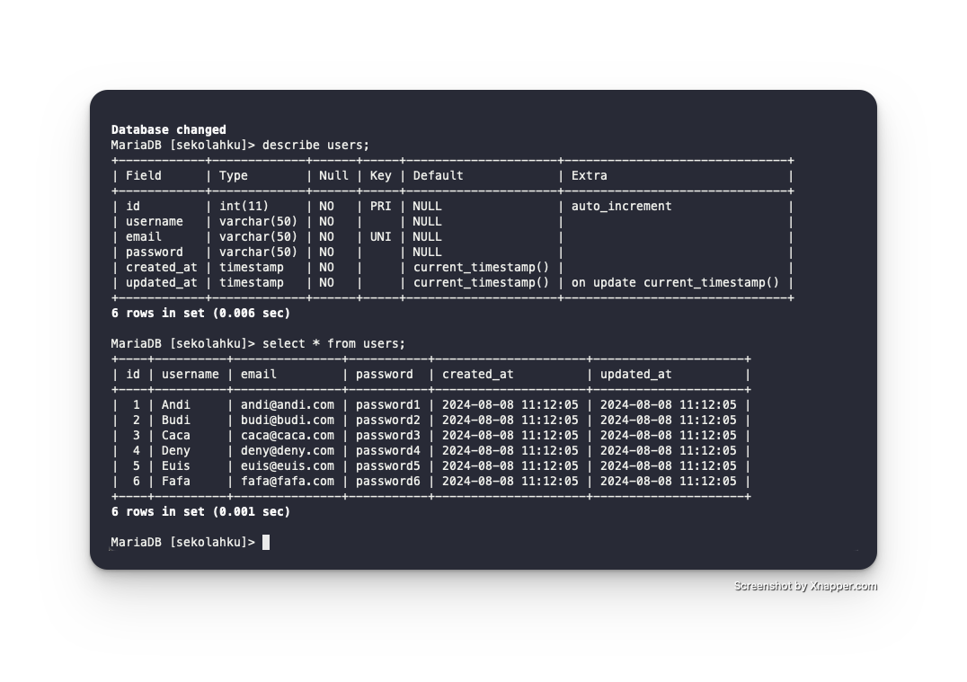

2. query create courses table

CREATE TABLE courses (

id INT(11) NOT NULL AUTO_INCREMENT,

course VARCHAR(50) NOT NULL,

mentor VARCHAR(50) NOT NULL,

title VARCHAR(50) NOT NULL,

PRIMARY KEY (id)

);

INSERT INTO courses (course, mentor, title) VALUES

('C++', 'ari', 'Dr.'),

('C#', 'ari', 'Dr.'),

('C#', 'ari', 'Dr.'),

('CSS', 'cania', 'S.Kom'),

('HTML', 'cania', 'S.Kom'),

('javascript', 'cania', 'S.kom'),

('python', 'bary', 'S.T.'),

('micropyhon', 'bary', 'S.T.'),

('java', 'darren', 'M.T.'),

('ruby', 'darren', 'M.T.');

output:

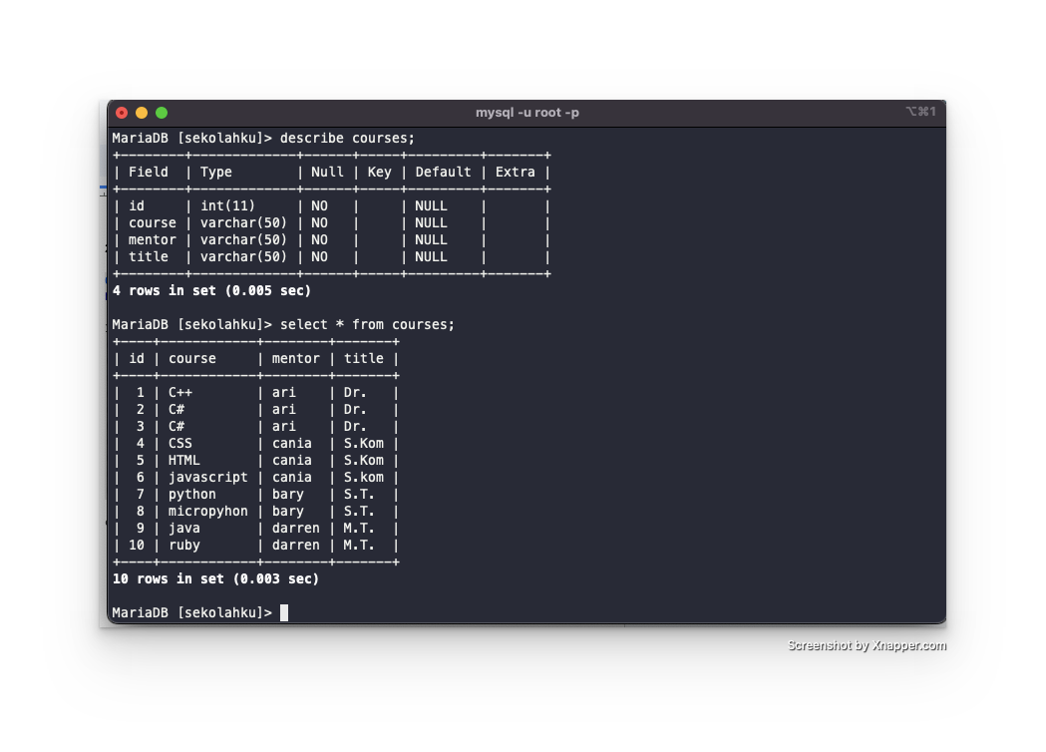

3. query create table useCourse relation with table users and courses

CREATE TABLE userCourse (

user_id INT(11) NOT NULL,

course_id INT(11) NOT NULL,

PRIMARY KEY (user_id, course_id),

FOREIGN KEY (user_id) REFERENCES users(id) ON DELETE CASCADE ON UPDATE CASCADE,

FOREIGN KEY (course_id) REFERENCES courses(id) ON DELETE CASCADE ON UPDATE CASCADE

);

INSERT INTO userCourse (user_id, course_id) VALUES

(1, 1),

(1, 2),

(1, 3),

(2, 4),

(2, 5),

(2, 6),

(3, 7),

(3, 8),

(3, 9),

(4, 1),

(4, 2),

(4, 3),

(5, 4),

(5, 5),

(5, 6),

(6, 7),

(6, 8),

(6,9);

output:  
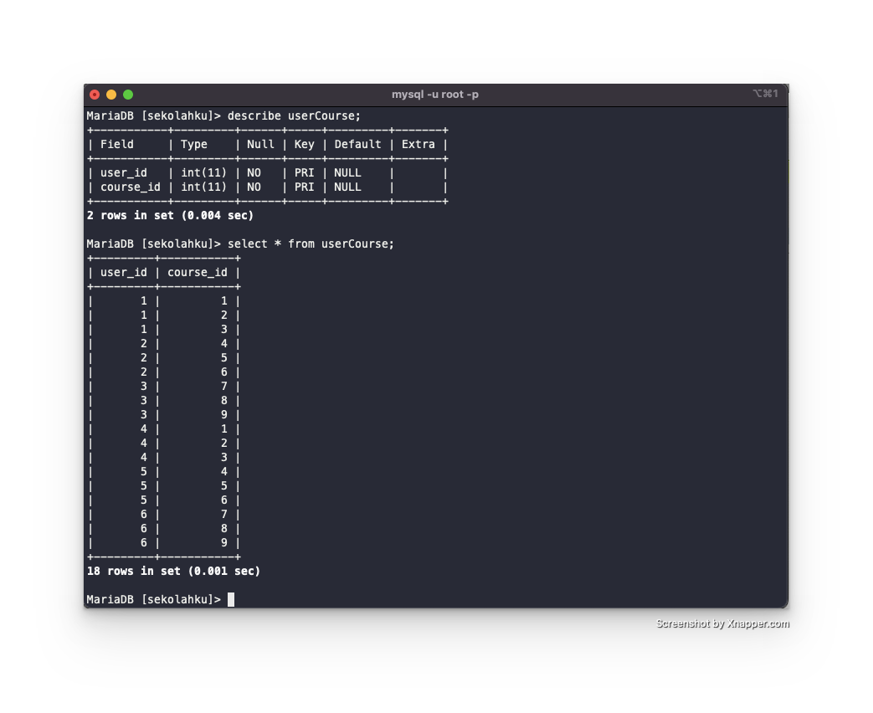

4. query

SELECT

u.username AS peserta_didik,

c.course AS mata_kuliah,

c.mentor AS nama_mentor,

c.title AS gelar_mentor

FROM

userCourse uc

JOIN

users u ON uc.user_id = u.id

JOIN

courses c ON uc.course_id = c.id;

output:  
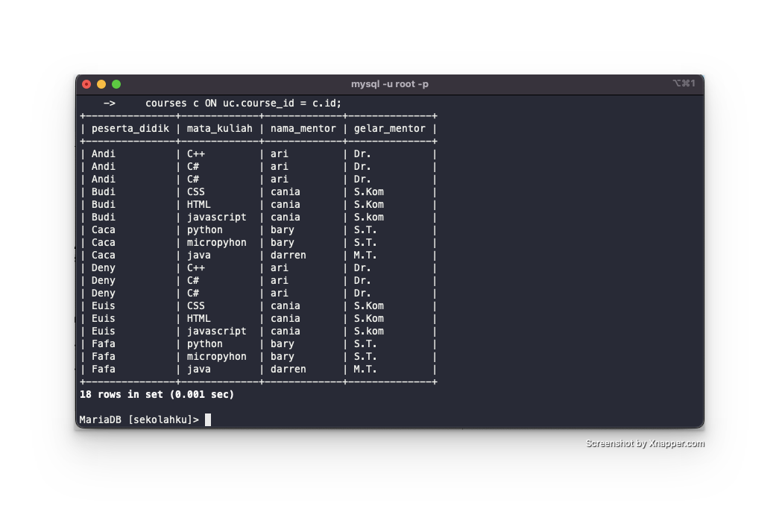

5. query

SELECT

u.username AS peserta_didik,

c.course AS mata_kuliah,

c.mentor AS nama_mentor,

c.title AS gelar_mentor

FROM

userCourse uc

JOIN

users u ON uc.user_id = u.id

JOIN

courses c ON uc.course_id = c.id

WHERE

c.title IN ('S.Kom', 'S.T.');

output:   
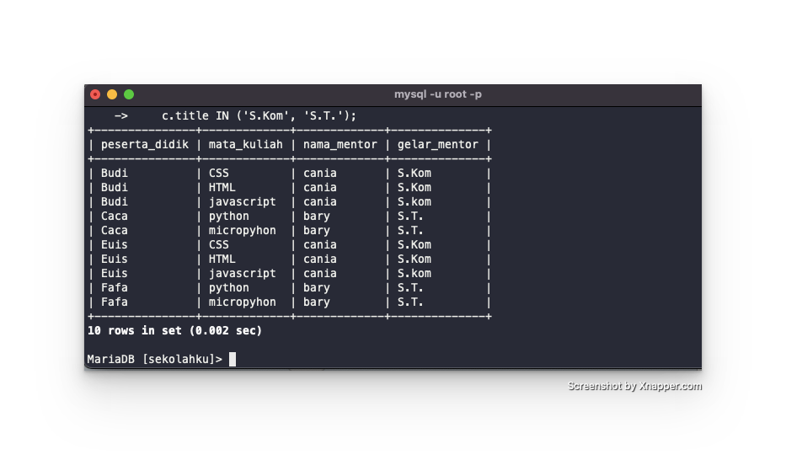

6. query

SELECT

u.username AS peserta_didik,

c.course AS mata_kuliah,

c.mentor AS nama_mentor,

c.title AS gelar_mentor

FROM

userCourse uc

JOIN

users u ON uc.user_id = u.id

JOIN

courses c ON uc.course_id = c.id

WHERE

c.title NOT IN ('S.Kom', 'S.T.');

output:  
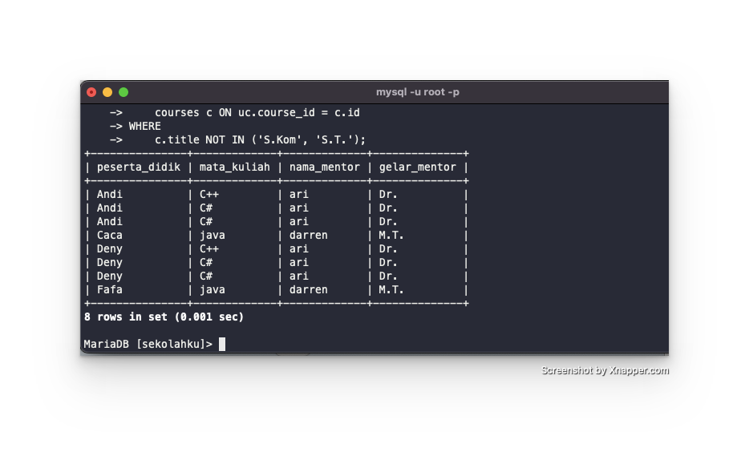

7. query

SELECT

c.course AS mata_kuliah,

c.mentor AS nama_mentor,

c.title AS gelar_mentor,

COUNT(uc.user_id) AS jumlah_peserta_didik

FROM

userCourse uc

JOIN

courses c ON uc.course_id = c.id

GROUP BY

c.course, c.mentor, c.title;

output:  
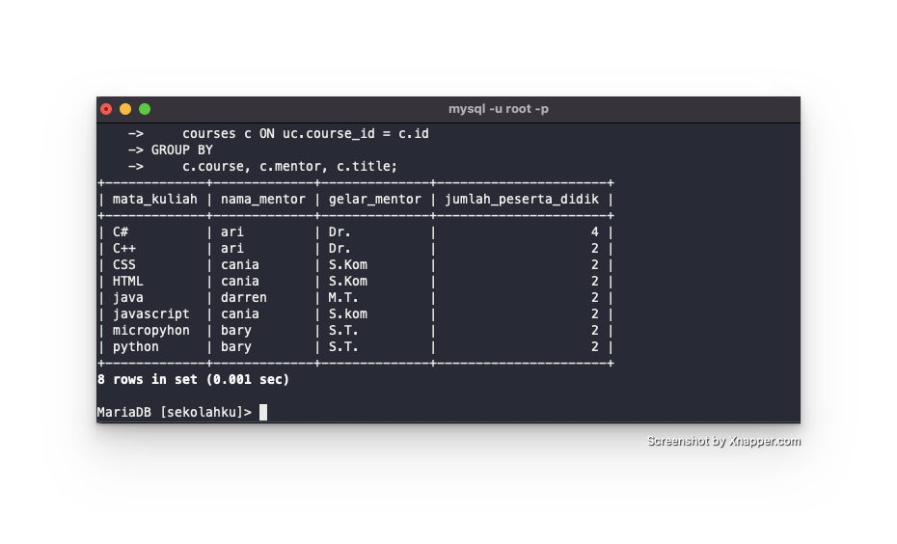

8. query

SELECT

c.mentor AS mentor,

COUNT(uc.user_id) AS jumlah_peserta,

COUNT(uc.user_id) * 2000000 AS total_fee

FROM

userCourse uc

JOIN

courses c ON uc.course_id = c.id

GROUP BY

c.mentor;

output:  
